
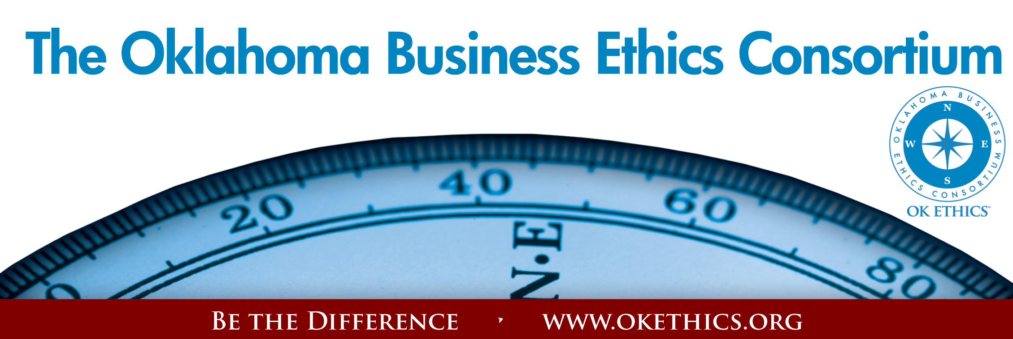
Oklahoma Business Ethics Consortium – October 21, 2009
Moore-Norman Chapter
I. Welcome & Kudos Shannon Hiebert, Vice President of Membership
OK Ethics Consortium Board of Directors
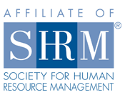
Vice President of Human Resources – Enterprise Rent-A-Car

Special thanks to our co-sponsors
The Sooner
Human Resources Society

Volunteers:
- Linda Streun – Chief Ambassador
- Lisa Giles, Eide Bailly, LLP – Name Badges & Registration
We appreciate Member Care Coordinator, Deborah Gavula

II. HAVE YOU RENEWED YOUR MEMBERSHIP?
Renew today – go to www.okethics.org or call 889-0498

III. Do you know someone who has been laid off?
OK Ethics is offering a free SCOUT membership (value of $75) to any business professional who has been recently impacted by a reduction-in-force. See the website or call 858-2233 for more details.

IV. STUDENT INITIATIVES Shannon Warren, Founder
OK Ethics
A) Student Ethics Bowl – November 13, San Antonio
Teams: Oklahoma City University – Meinders School of Business
Advisor: Dr. Barbara Crandall
University of Central Oklahoma –
Advisor: Dr. Katherene Terrell

Corporate representatives: Tony Blasier, Chesapeake
Bob Byrne & Shannon Warren, OK Ethics

- Corporate Ambassadors Needed for University Initiatives
Your presence shows the importance of Oklahoma values
of integrity at work!
What’s involved?

  - Attend meetings of student chapters
  - Encourage student attendance at OK Ethics events
  - Serve as mentor to student chapters
  - Help launch new chapters

University of Tulsa | University of Oklahoma | Oklahoma State University
Oklahoma City University | Southern Nazarene University | Rose State College
University of  Central Oklahoma | OBU International | East Central University

Interested? Complete a blue form (center of table) and drop it off at the registration table as you exit.

- Watch for upcoming student chapter actives on our website
UCO-Ethics Meeting  Monday, October 26, 2009  2:00 pm Social, 2:30 pm | OU - First Annual Integrity Forum  November 13, 2009  3:00 - Program
Speaker: Dr. John Maisch  Troy Smith Lecture Hall  College of Business  University of Central Oklahoma  Please register to receive parking pass. | OU campus in Neilson Hall, Room 170  This panel is being organized by the student chapter of OK Ethics at the University of Oklahoma, also known as the UOSA Honor Council, a student organization that serves as the student voice of academic integrity and ethics on campus. The speakers on this panel will essentially talk about how integrity is a part of their profession, how ethics are factored into their daily operations, and perhaps give some examples of when they have dealt with a sticky situation with integrity vs. taking “the easy way out.”  This event is open to the public.
To register: Contact kterrell@uco.edu | Questions? Contact breea.bacon@ou.edu

- KEYNOTE SPEAKER: Introduction by Shannon Hiebert

Carolyn Shockley, Norman Regional Health Care Systems
“Ouch! RX for Ethical Injuries”

General Disclaimer: Members of the Oklahoma Business Ethics Consortium frequently share information concerning various issues and developments that may have legal implications. The discussions, commentary, and handouts at Consortium meetings or presentations to other organizations are for general informational purposes only. They cover only some aspects of the subject topic, and do not constitute a complete legal analysis of the topic or how it might apply to any particular set of facts. Before taking any action based on information presented during a Consortium event, participants are encouraged to consult a qualified attorney.

The observations and comments of presenters at Consortium meetings and networking are the views and opinions of the presenter and do not constitute the opinion or policies of the Consortium or any of its members. Presenters are respectfully requested to avoid profanity, preaching, politics and self-promotion during their lectures.

VI. UPCOMING EVENTS:
November 4 – “When Faith & Work Values Collide”
Recommended for 1 CPE in Ethics
LOCATION CHANGE FOR NOVEMBER ONLY
Jim Thorpe Center on Lincoln
Oklahoma City
Father  Rick  Stansberry  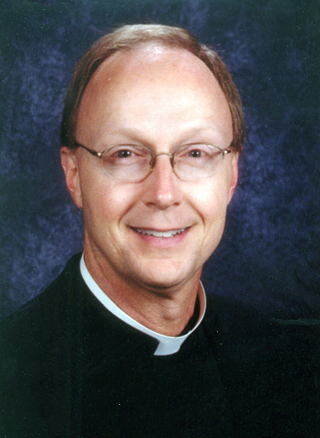  Christ the King  Catholic Church | Andrew Tevington  Our Faiths Columnist  The Oklahoman  Mr. Tevington’s book will be on sale and he will be available to sign it.   | John Cougher  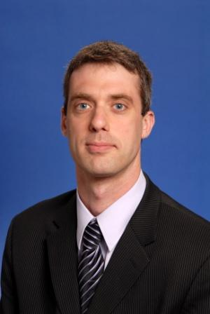  Director of Development,  Jeannine Rainbolt College of Education,  University of Oklahoma  (John spent six years in a residential Zen Buddhist facility in LA)
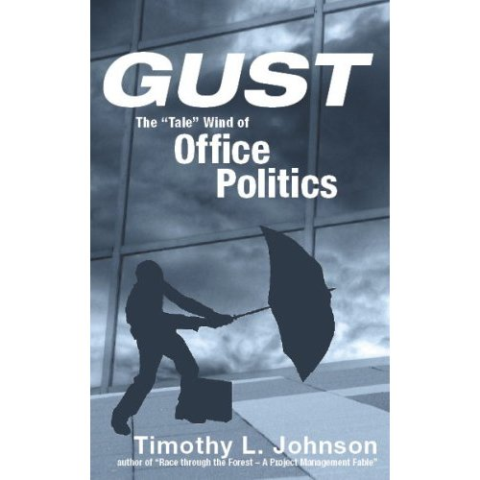
“Ethics & Office Politics”
Featuring author Timothy L. Johnson
December 9
Recommended for 1 CPE

You’ve been there. You know you have. You’re plugging along, doing your job, making progress, and then all of a sudden… BAM! You feel like the victim of a hit-and-run (and to some extent, you are). You’ve just been nailed by office politics.

In this economy and job market, it is an imperative skill to master the art AND science of office politics. Instead of “fight or flight,” one must look at office politics as a process to be solved rather than as a fight to be won. And it can be solved ethically and morally. Tim Johnson will help you find the strength to fight back.

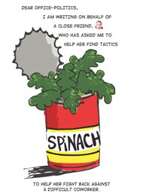
During this presentation, Timothy Johnson will share the process of using GUST to understand your office politics situations better. You’ll see how much control you have over the GAME, learn the importance of UNDERSTANDING the players and motives, determine the best STRATEGY for addressing your specific situation, and then figure out how to TAKE ACTION without compromising your integrity.

We all face office politics situations. From bullies who overstep their bounds to office prima donnas who think everything revolves around their egos, from passive-aggressive types to saboteurs, you’ll see new approaches for framing and handling your office political situations. The real value is learning how to treat office politics as a proactive strategic tool rather than a reactive weapon.
REGISTER OR JOIN TODAY: WWW.OKETHICS.ORG or call 889-0498

